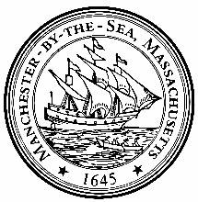
Received by the Town Clerk on October 29, 2024 at 10 AM.

Manchester-By-The-Sea
Meeting Posting
Notice of Public Meeting – (As required by M.G.L.Ch.30A §18-25)
Board/Committee: MBTA Task Force Communications and Outreach Subcommittee
Day & Date: Thursday October 31, 2024
Time: 10:30 a.m.
Location: Town Hall, Room 7 & VIRTUAL
Join Zoom Meeting
https://us06web.zoom.us/j/84465557166?pwd=VyStPWdF73pbRKbINsLfof9rUrFEs7.1
Meeting ID: 844 6555 7166
Passcode: 856459
Dial In: +1 301 715 8592 US

AGENDA
Call to Order
Outreach Events: - Ms. Marletta/Ms. Philbrick
- PB Public Hearing – October 28 - debrief
- Public Forum – November 7
- Rotary – November 13 7:30 a.m.
- Informational Table
- Town Meeting prep.
Communication Tools:
- Status Individual District Videos update
- FinCom Analysis
- Direct Mail: – Ms. Marletta
- Update FAQs – Ms. Philbrick
- Handouts for STM
- Others
- Grant information

Review of Any Completed Minutes: October 7, 17, 24, 2024
Next Meeting
Public Comment
Any other administrative matters that could not reasonably have been anticipated in advance of the required 48-hour posting.
Adjourn

